SOUTHWEST OKLAHOMA

REPUBLICAN WOMEN

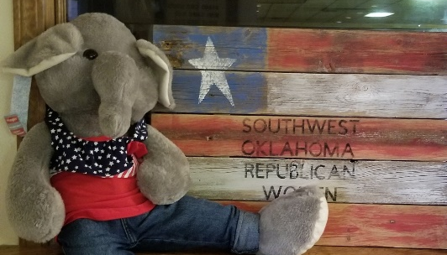
MEMBERSHIP FORM

Name ___________________________________

Address ___________________________________

___________________________________________

Phone (H) __________________________

Phone (Cell) ________________________

Email _____________________________________

____ Membership $ 35.00
____ Associate Membership* $ 15.00

*Associate members are women who are
members of another Republican Women's
club or male members.

Please return this panel and make checks payable to SWOKRW.
Mail to:
1509 N. Main #136
Altus, OK 73521
swoklahomarw@gmail.com

Enjoy the camaraderie of like-minded women who share your political views. We welcome all Republicans for membership.

